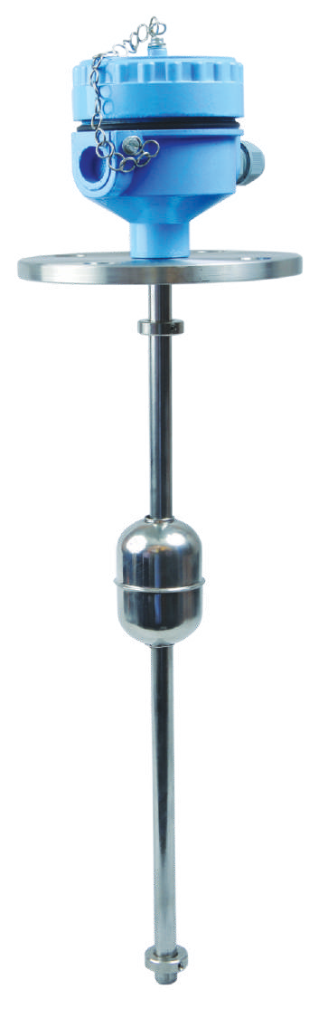

V









- RS 485
- Resistance as per customer request

Float Level Transmitter consists of nonmagnetic sealed stem containing series of reed switches and resistor, Float carrying magnet, mounting adaptor (or flange) and enclosure containing electronics.

Consider our Float Level Transmitters for all your continuous liquidlevel monitoring needs like Water, Diesel, Lube oils, Fuels, Chemicals and Petrochemical liquids.


Float Level Transmitters does not work satisfactorily in highly contaminated liquids ans liquids with high viscosity.

DC POWER
4 - 20 mA
-
-
TRANSMITTER
LEVEL



B : 3 wire 0 - 10V DC
FLOAT
STEM

E C T R O N I C S

DC POWER SUPPLY
USER INSTRUMENT
O/P
-
LEVEL TRANSMITTER

R - Resistive O/P 4 - RS 485




3 - 34mm Nylon Foam
Mounting Material
4 - 40mm dia SS 316
5 - 52mm SS 316
6 - 68mm SS 316
P - 50mm dia PP
PP - Polypropylene


Mounting
10 - 100 dia 80 PCD
75 - 75 dia 60 PCD
1D - 1” Table ‘D’ 1A - 1” ANSI 150#
2D - 2” Table ‘D’ 2A - 2” ANSI 150#
ND - 2 ” Table ‘D’ NA - 2 ” ANSI 150# 4B - ” BSP
1B - 1” BSP NB - 1 ” BSP 2B - 2” BSP
NS - Non std mounting

Levtron Instruments Pvt Ltd.
Office No 2, 1st floor, plot no 6, Pandhari Industrial estate, Shivane. Pune 411023,
Contact: 09579430012 / 9730042725 E-mail: sales@levtron.in ; Website : www.Levtron.in
n ISO 9001:2015 Company

